Background
This instructor guide is intended to be used by a healthcare practitioner (i.e. doctor, nurse practitioner or nurse) in a clinical setting following a diagnosis of a life threatening food allergy. The student in this case is parent or care giver of a new diagnosed child with food allergies. The healthcare provider will explain anaphylaxis and describe the symptoms which may occur following an exposure to the food allergen. The parent will learn the steps of the proper use of the prefilled epinephrine syringe (EpiPen®) and have an opportunity to practice using an EpiPen® trainer on the child in the office. He or she will also work with the healthcare provider to fill out the food allergy action plan. Before leaving the office, the instructor will ensure the parent understands who should have an EpiPen® (daycare provider, school, etc.) and how to properly store them.
The six major components of Behavior Modeling are:
- Prescribed Critical Steps—these are a list of steps which must be performed to complete the desired behavior or assignment.
- Credible Model—a video showing the steps performed correctly in a realistic situation.
- Skills Practice Exercises—the student will practice the steps in order to become comfortable performing the behavior.
- Specific Feedback and Social Reinforcement—as the student demonstrates competence in a skill, the instructor assists in positive and actionable feedback from other peers.
- Transfer strategies—allows the student use the skills in progressively more difficult situations.
- On the job reinforcement—these include ways to reinforce the skill and practice once the training is complete. They may include instructions and guides or videos.
From: Medsker, K. L., & Holdsworth, K. M. (2001) Models and strategies for training design. Silver Spring, MD: International Society for Performance Improvement.
Prescribed Critical Steps: The instructor will describe the symptoms of anaphylaxis, demonstrate the proper administration of a dose of epinephrine using an EpiPen®, and the steps to take following the use of the EpiPen®.
Credible Model: The video, produced by Nationwide Children's Hospital's allergy clinic and featuring Dr. Daniel Scherzer, describes the symptoms of a serious allergic reaction, the proper use of the EpiPen® and the steps to take afterward. Children with allergies have a starring role and provide part of the narration of the video. The narration is subtitled and uses common terms, not medical jargon.
Skills Practice: The parents (students) will have an opportunity to practice using an EpiPen® trainer to become comfortable using the device quickly.
Feedback and Social Reinforcement: The parents will practice on each other and provide feedback and coaching. They will decide together where to store the device at home.
Transfer strategies: Ultimately the parent may need to use the skills in stressful real life scenario, which is the ultimate test of their mastery of the skill. Meanwhile, they will become the instructor teaching grandparents, babysitters, coaches, and the parents of the child’s friends, when and how to properly use the device.
On the Job Reinforcement: Several pages of information, links to the video and the Food Allergy and Anaphylaxis Network, a Food Allergy Action Plan, and a training device will all serve as tools for reinforcement outside the doctor’s office.

Food Allergies and the EpiPen®
Purpose:
This course is designed to help healthcare providers explain food allergies to newly diagnosed patient’s parents. The instruction on symptoms and steps to take before seeking emergency care is designed to be delivered in the office. The parent or caregiver should learn and be able to demonstrate the steps necessary to properly deliver a dose of epinephrine quickly at the first sign of symptoms. He or she will practice using an EpiPen® trainer. Finally, with the help of the healthcare provider, the parent will properly complete the allergy action plan which can then be shared with all the people who will be caring for the child.
Learning Objectives:
The student should be able to list and describe possible symptoms which indicate a serious reaction to an exposure to the food allergen.
Given an EpiPen® trainer device, the student should demonstrate the proper administration of a dose to a child’s outer thigh in less than one minute.
The student should be able to list the steps which should be taken following the use of an EpiPen®.
The student should complete a food allergy action plan, listing the patient’s weight, date of birth, allergens, and steps which should be taken in the event of an exposure.

Materials:
- Anaphylaxis Awareness Flyer
- Laptop or tablet computer with Wi-Fi access for viewing instructional videos
- EpiPen®
- EpiPen® training device
- Food Allergy Action Plan
- Take home sheet with links to the videos and information about support groups, advocacy groups and resources

These materials should provide you with the tools in one package to help the parents of a newly diagnosed patient with life threatening food allergies understand how to best care for their child. The diagnosis can have been the result of a recent life threatening reaction to a food, so the parents may not be in the best emotional state to receive this information in the office—all the links, videos, EpiPen® trainers and flyers should accompany them home so that they may review this vital information again in the future. The diagnosis may also have come without any symptoms, so it is important to stress that they must be prepared in the event of a future exposure which results in life threatening symptoms. Some parents may not fully believe the diagnosis since their child may not appear “sick”, but it is your job to convince them that even small amounts of their child’s offending allergen may result in serious symptoms which will require an immediate response and emergency care. They must be prepared to act quickly.

Begin by answering any questions and reassuring parents (and perhaps the patient) that with strict avoidance of the allergen, their child will be safe and healthy. Explain that you are all members of the team of people who will keep your child safe in the event of an accidental exposure.

Watch the video: link to video describing food allergies and how to properly use an Epi Pen
4 minutes 25 seconds
Practical: Show the parents the EpiPen®.
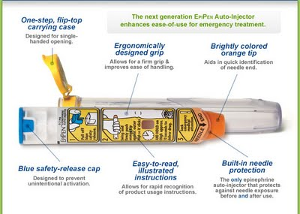

Point out the expiry date, where the needle comes out, and how to take off the safety cap. Warn them that once the blue cap is removed, the next thing the orange tip touches will be injected with the drug, so remove the safety cap last.
Instruct the parent on how to store an EpiPen®: room temperature, not refrigerated or in a hot car.
Show on the child’s outer thigh where the dose should be given, not in the buttocks.
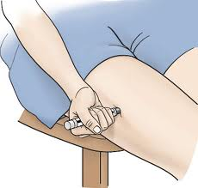
Have the parent demonstrate holding the child’s leg steady, jabbing the EpiPen® trainer into the leg until it clicks, and counting to ten.
Have the parent practice until they can administer the dose in less than a minute. They may practice on their own leg or on the leg of the other parent.
Instruct the parent that after the dose is given, the child must go to the emergency room.
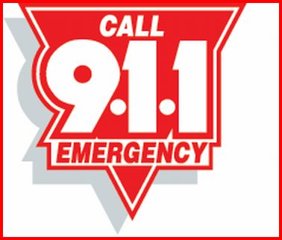

Feedback: Once one parent is comfortable administering the EpiPen®, the other parent should have an opportunity to repeat the steps listed above, receiving coaching from the practiced parent. Both parents should agree where the EpiPen® will be stored in the house.

Symptoms: Discuss the symptoms which may occur when a reaction takes place.
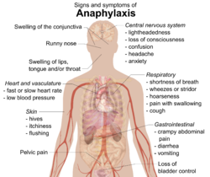

Review the anaphylaxis flyer (link to document discussing anaphylaxis symptoms). Talk about food labels and stress that every adult needs to read labels and not make assumptions about what foods may contain. (link to document discussing how to read food labels)
Practical: Using the child’s medical file, complete the Food Allergy Action Plan together. (link to food allergy action plan)
Discuss other locations where the child may spend time (school, daycare, relatives etc.), which should also have an EpiPen® available and a completed Food Allergy Action Plan.

Review: Ask the parents to describe and list the symptoms of a reaction, have each parent demonstrate the proper administration of the EpiPen®. Have the parents explain what should happen after the dose is given. Review with the parents the names of other adults in the child’s life who will need to have a Food Allergy Action Plan and EpiPen®.

Food Allergy Resources for Review at Home
EpiPen® Video: Link to video discussing food allergies and the proper use of an Epi Pen


www.foodallergy.org

Food Allergy Action Plan
https://www.foodallergy.org/files/FAAP.pdf

Anaphylaxis Awareness Flyer
link to an anaphylaxis awareness flyer document

How to Read a Label
link to a document describing how to read a food label

